  - Free University Berlin – winter study program
귀국 보고서

1. Course Overview
The course was conducted at the FUBiS campus in Berlin. Classes were held three days a week, starting at 9 a.m. In the morning, there were three hours of lectures, followed by an additional one and a half hours of class in the afternoon. The course was taught entirely in English, and there were approximately 20 students in the class.
Once a week, we participated in field-based classes by visiting museums, related companies, or other relevant sites, which was a very valuable experience. Over the three-week program, the school provided not only academic classes but also weekend tours such as a Potsdam tour and a Berliner Unterwelten tour. In addition, several light and optional workshops were offered on weekdays.
The course I took was Urban Economics, which introduced economic perspectives on urban growth and development in an accessible way. Besides this course, students could choose from a variety of classes such as German language courses, sustainable management, and law, society, and politics. Each course had a different teaching style, and classes were conducted in a comfortable atmosphere with students from many different countries.
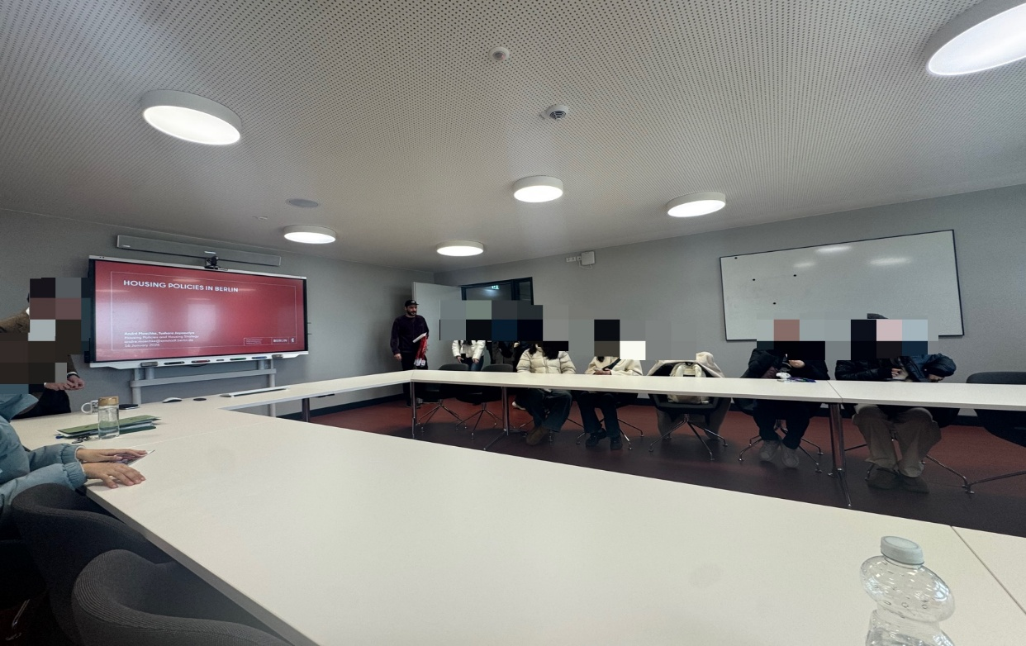

2. Course Content
The Urban Economics course covered a total of twelve topics. These included urban growth, the determination of city size, land use, transportation, and crime. The professor analyzed all topics from an economic perspective and explained them clearly using various examples and graphs.
Grades were determined based on a midterm exam and a final exam. The exam questions were mostly descriptive and required students to apply the concepts learned in class rather than simply memorizing them.

3. Accommodation
Due to a power outage in Berlin, I had to stay at a temporary youth hostel for about three days after the semester began. After that, I moved into my original accommodation, a single room in a university dormitory. The room was spacious and clean, and both the kitchen and common areas were well maintained.
However, during the first week, the power outage caused extremely cold conditions, making it impossible to live without an electric heating pad. In addition, the shower facilities were not in good condition, and the pillow and bed were not in a satisfactory state. The dryer was also broken, so I had to go to a laundromat located far from the dormitory to do my laundry.
The dormitory was about an hour away from the campus by public transportation. It required two to three transfers, and due to frequent changes and delays in Berlin’s transportation system, I often had to find alternative routes. Nevertheless, overall, I believe the dormitory was suitable for staying for about three weeks. It was convenient because supermarkets, hospitals, and other facilities were located nearby.
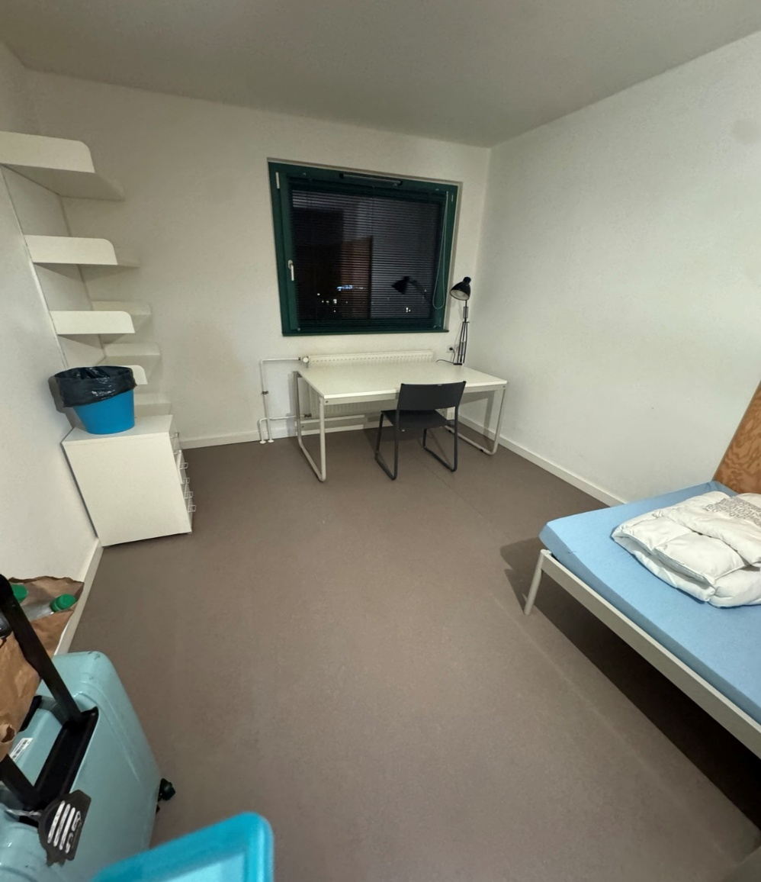

4. Leisure Activities
Since classes were held only three days a week, I was able to travel or engage in other activities during the remaining four days. I spent much of my time visiting Berlin’s famous museums and art galleries, sightseeing at major tourist attractions, experiencing local culture in areas frequented by Berlin residents, and trying traditional Berlin food.
During weekends or longer breaks, I traveled to other cities in Germany such as Frankfurt, Heidelberg, and Dresden. I also took a bus trip to Prague in the Czech Republic, which is a nearby country. Balancing coursework with travel made the experience more meaningful and enriching than traveling alone without academic commitments.

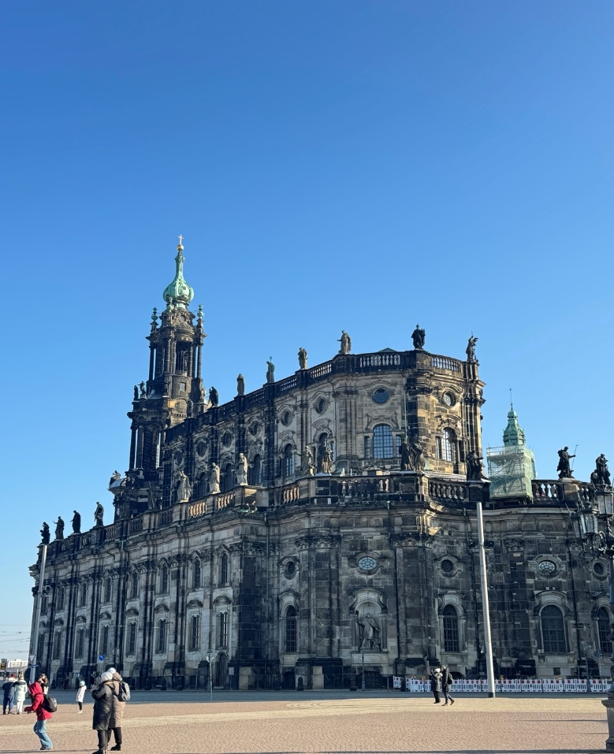
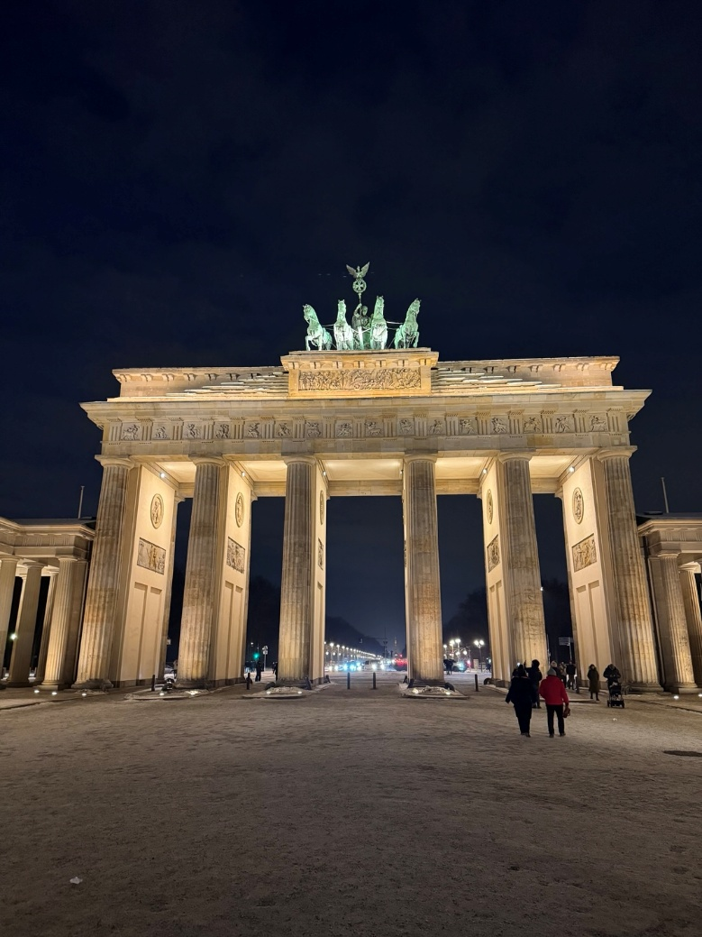

5. Reflection
I had considered participating in a long-term exchange program for more than one semester, but instead decided to join this short-term program. After completing this experience, I became determined to participate in another exchange program related to my major during a regular semester.
This experience was extremely meaningful to me, as I was able to meet wonderful people, take high-quality classes, improve my English skills, and experience a new culture.


